**Array**

* Arrays are used to stores group of homogeneous and fixed size elements.
* The size of Array is fixed it means once we created Array it is not possible to increase and decrease the size.

**Syntax**

datatype arrayname[] = new datatype[size];

**Example:**

int arr[] = new int[5];

**Types of Array**

* Single Dimensional Array
* Multidimensional Array
* Jagged Array

**Single Dimensional Array**

* One dimensional array is a list of variables of same type that are accessed by a common name.
* An individual variable in the array is called an array element.

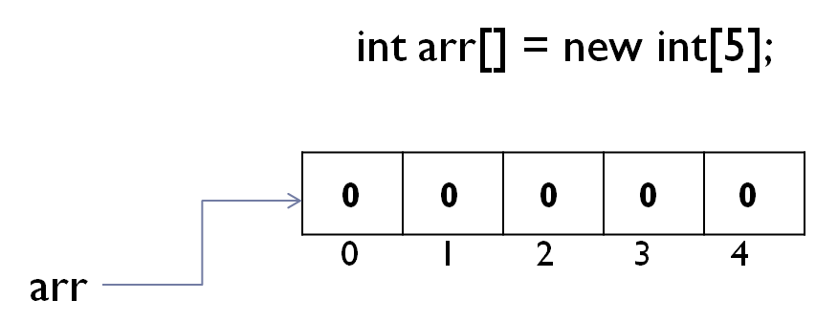

**Example**

class ArrayDemo{

public static void main(String args[]){

int arr[] = new int[5];

System.out.println("Display Array Elements: ");

for(int i=0;i<=4;i++){

System.out.println(arr[i]);

}

}

}

**Reading data from the keyboard using Scanner class**

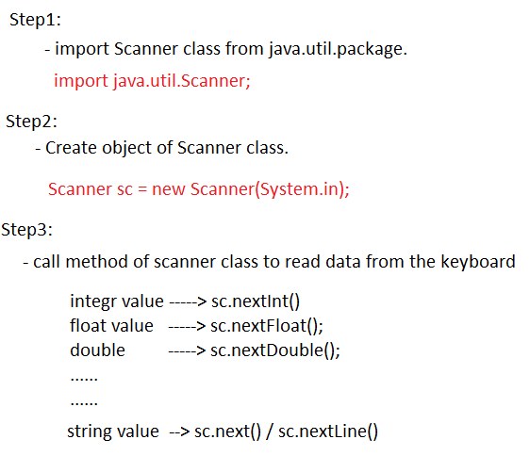

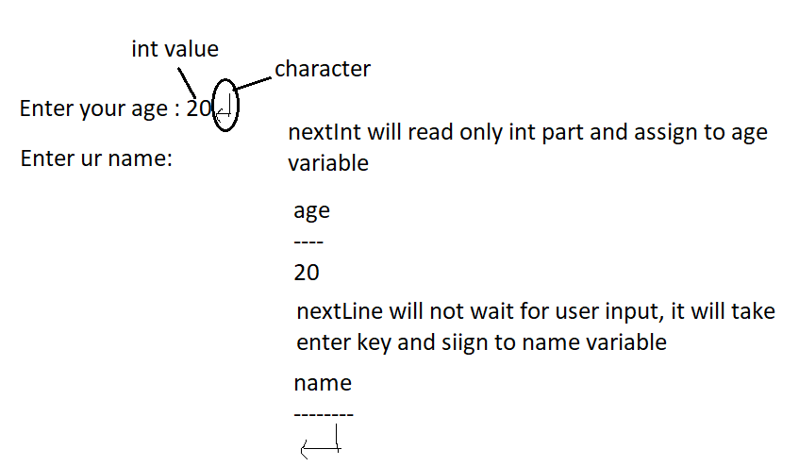

import java.util.Scanner;

class Employee{

public static void main(String args[]){

Scanner sc = new Scanner(System.in);

int age;

String name;

System.out.print("Enter your age : ");

age = sc.nextInt();

sc.nextLine();

System.out.print("Enter your name : ");

name = sc.nextLine();

System.out.println("*** Employee Details ***");

System.out.println("Your age is : "+age);

System.out.println("Your name is : "+name);

}

}

**Read and Display Array Elements**

import java.util.Scanner;

class ReadArray{

public static void main(String args[]){

Scanner sc = new Scanner(System.in);

int arr[] = new int[5];

System.out.println("Read Array Elements : ");

for(int i=0;i<=4;i++){

arr[i] = sc.nextInt();

}

System.out.println("Display Array Elements : ");

for(int i=0;i<=4;i++){

System.out.println(arr[i]);

}

}

}

**Array Initialization**

* Giving values into the array at the time of declaration is known as initialization.
* The values are enclosed by braces and separated by commas.

int arr[] = {10,20,30,40,50}

**Example**

class ReadArray{

public static void main(String args[]){

int arr[] = {10,20,30,40,50};

System.out.println("Display Array Elements : ");

for(int i=0;i<=4;i++){

System.out.println(arr[i]);

}

}

}

**2-D Array**

In java multidimensional arrays are not implemented in matrix form, they implemented by using array of array concept. This approach will improve memory utilization.